Steps to Complete the Task Successfully

1. Access Jenkins
- Click on the Jenkins button from the top bar.
- Log in using:
  - Username: admin
  - Password: Adm1n321
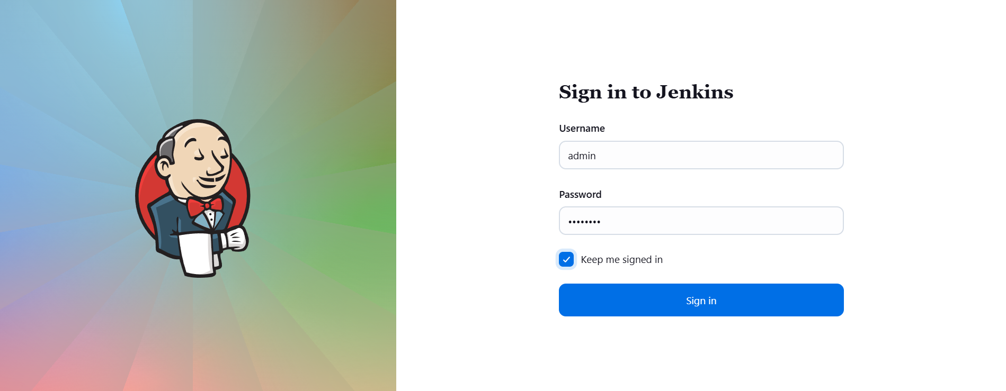

2. Verify Required Plugins
- Navigate to Manage Jenkins → Manage Plugins.
- Ensure plugins required for job execution (e.g., SSH, Pipeline, or Shell execution) are installed.
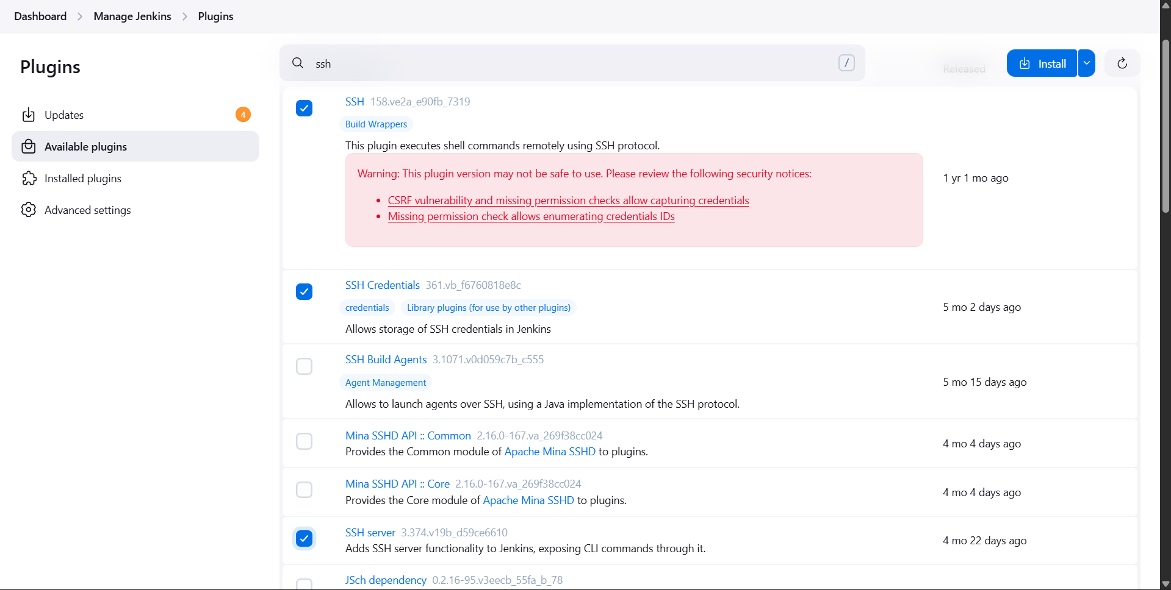
- If plugins are installed/updated:
  - Select Restart Jenkins when installation is complete and no jobs are running.
  - Refresh the UI after restart.
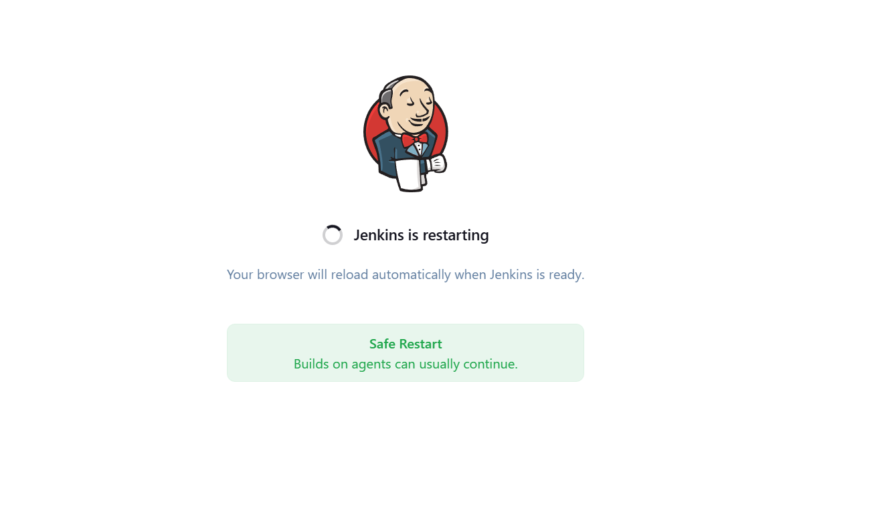

3. Create a New Jenkins Job
- Click New Item.
- Enter the job name:
install-packages
- Select Freestyle project.
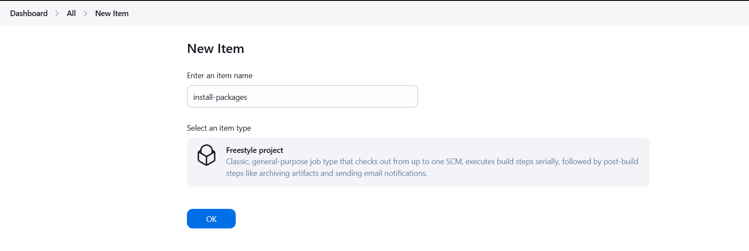
- Click OK.

4. Add a Build Parameter
- Go to This project is parameterized.
- Add:
  - Parameter Type: String Parameter
  - Name: PACKAGE
  - Description: Name of the package to install
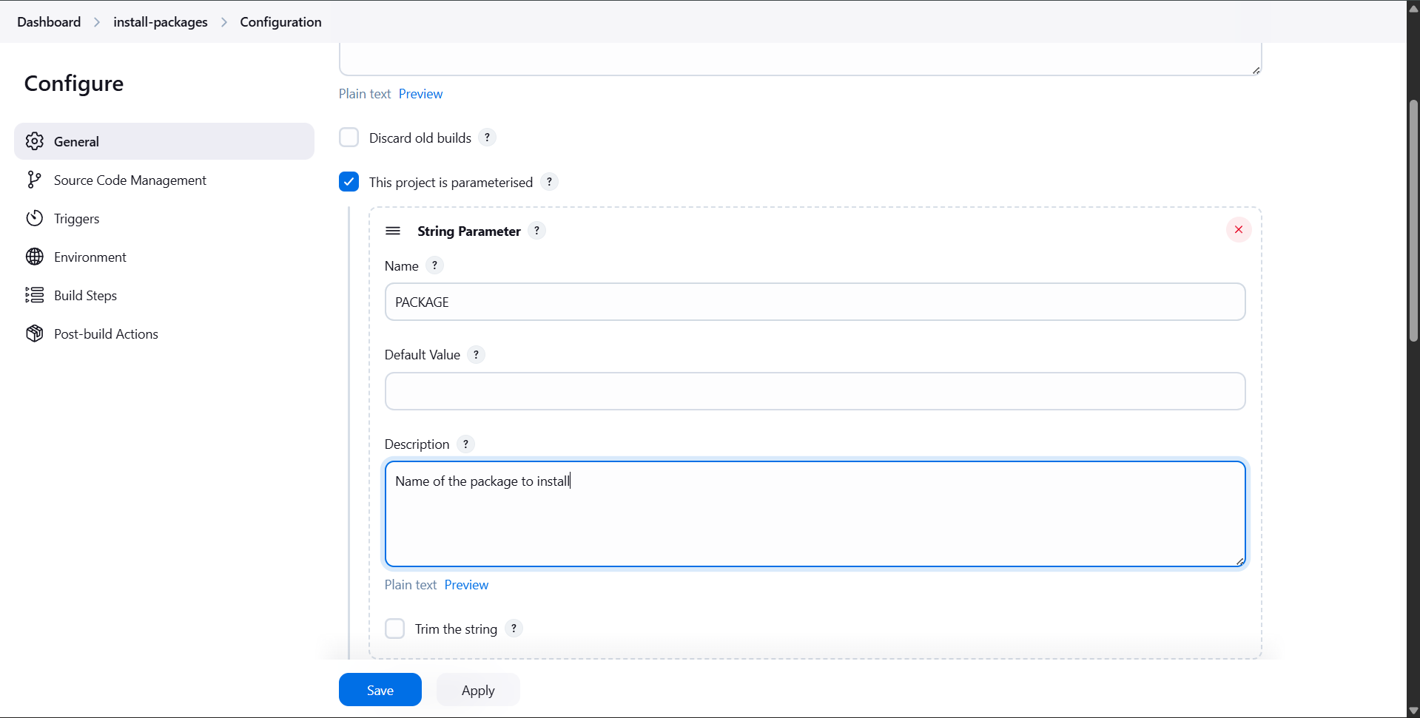

5. Configure Package Installation
- In the Build section, add a build step (e.g., Execute shell).
- Configure the command to:
  - Connect to the storage server.
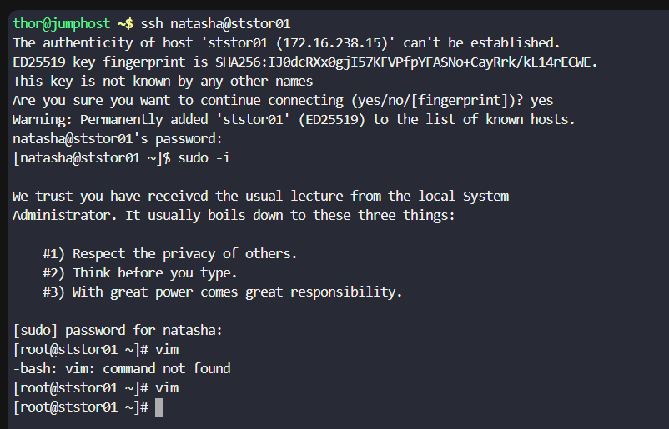
  - Install the package using the value passed in $PACKAGE.
Example logic:
  - Use package manager (yum / apt) depending on OS.
  - Reference the parameter as $PACKAGE.

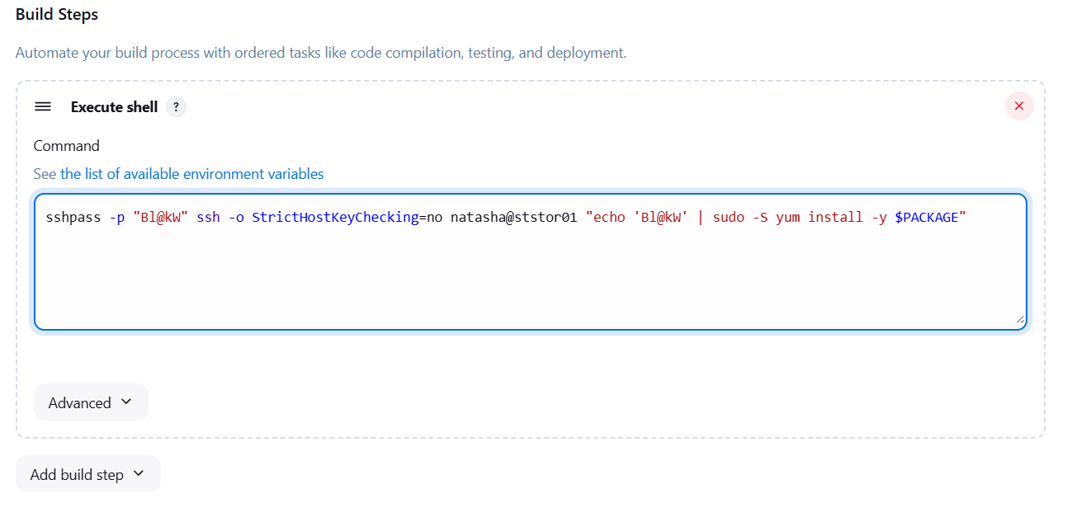

6. Save and Build the Job
- Click Save.
- Select Build with Parameters.
- Enter a valid package name (e.g., httpd, vim, nginx).
- Trigger the build.
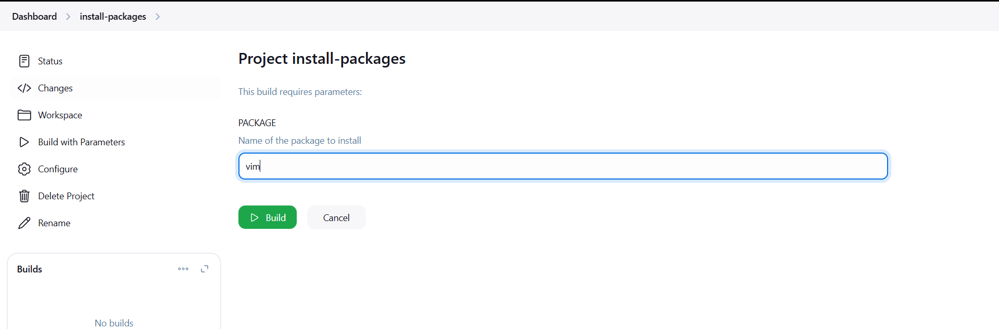

7. Verify Successful Execution
- Check Console Output to confirm:
  - Server connection is successful.
  - Package installation completes without errors.
